

**E-PROJECT-DEVELOPMENT TEAM**

* PROJECT TITLE

**MARU DRY FRUITES**

* TEAM MEMBERS
* Hafsa Shahid
* Sajal Rashid
* Latif Pervaiz



* PROFESSOR NAME
* Hassan Ali
* BATCH CODE
* PR2-2024-02F
* SEMESTER
* CPISM



CERTIFICATE OF COMPLETION

This is certify that Hafsa shahid , Sajal Rashid,

& Latif Pervaiz have successfully completed their

ACCP 1st semester (CPISM) E-Project.

Submitted to: Aptech Computer Education

On

August-27-2024



ACKNOWLEDGMENT

A quick responsive team with a friendly environment yet consistent pace of work is what the world demands from us IT professionals . However, in a situation like now busy schedules and abstracted location become a known barrier for causing a delay in the submission of most of the project , forcing us to grasp better and more effective alternative to prove our efficiencies .

We would like to acknowledge all those who have given moral support and helped me make the project a success.

Also we would like to express our teacher **SIR HASSAAN ALI** for his guidance and constant supervision as well as providing necessary information regarding the project.

I also express my sincere gratitude to the E-project Team at the Aptech Head Office

ABRIDGEMENT

I and my crew worked for almost a week so the venture we started could come to an end. During this span of time my team and I forced some completely unpredictable complication which enhanced our knowledge about coding errors and its omission . We failed on certain points however at last we advanced to the final progress.



PROBLEM STATEMENT

The dry fruits are rich in vitamins and proteins; they also boost immunity and prevent lifestyle diseases such as cholesterol and diabetes. Most dry fruits are rich in minerals, proteins, fiber and vitamins add to that they are tasty and delicious too. Dry fruits are excellent and healthy substitute for daily snacks. Maru dry fruits - a local shop in the market is pretty old and needs website for advertising the products, providing information about them so as to attract more and more customer

REQUIREMENT SPECIFICATION

The Web site is to be created based on the following requirements.

1. The home page must be designed with beautiful color combination with all the

required links defined properly. Also, all the section of the webpage must be in

used to avoid the blank space.

2. It should include all the varieties of dry fruits, its rate as per quality.

3. Site should also provide nutrition information about each and every dry fruit.

4. Customer should be able to buy online, quantity as specified by them.



5. The site should display various offers / discounts announced time to time

6. It should also include the festival gift packs.

7. About us, Contact Us, Disclaimer must be included.

8. Contact us page: contact us details with location should be displayed using

Geolocations API (e.g. Google Maps).

9. Creating an account facility can also be added.

10. Dummy procedure for buying to be added.

11. Sitemap must be added.

12. Navigation of the project must be made smooth.



Hardware/ Software Requirements

**Hardware**

* A minimum computer system that will help you access all the tools in the courses is a Pentium 166 or better.
* 64 Megabytes of RAM or better.

**Software [Either or Combination as per Course/Sem]**

* Notepad/HTML editor/Coffee Cup

• Angular / Angular JS / React / Bootstrap

• Dreamweaver / Figma

• MS IE / Chrome / Firefox / Netscape /MS Edge

Architecture and design of the system

DEVELOPERS GUIDE

Using HTML , CSS ,BOOTSTRAP and JAVASCRIPT on this project was a very convenient yet a simple way to express our creativity in different sorts of manner . This website is based on various classes and ids set in a consecutive manner with suitable names and a very readable coding structure so it could be smooth too understand it and make changes if necessary.



SITE map



USER GUDE

**NAVIGATION BAR**

The navigation bar is the host of the website which will help you explore the rest of site. There are some of the option like HOME, SHOP,ABOUT US,CONTACT US, FAQS, DISCLAIMER each of them which leads to another side of our project.

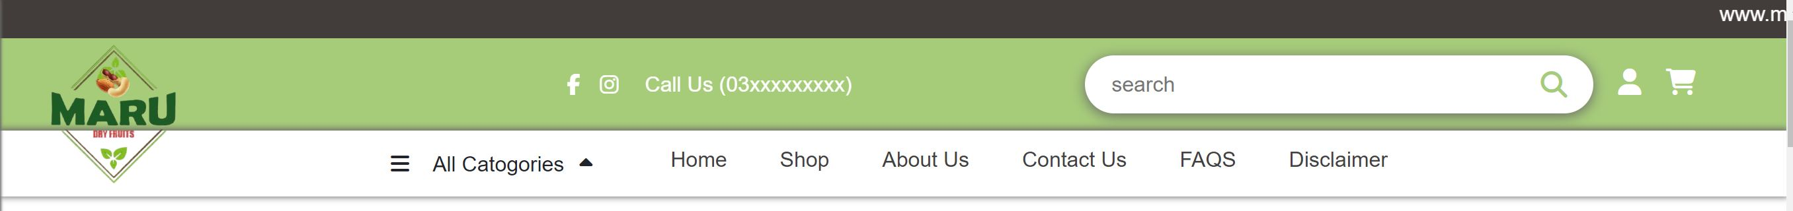

**HOME**

Home page is a main page of the website or could be termed as the industry page containing some of our information and navigation bar at the top working as a gateway to other pages of the site.



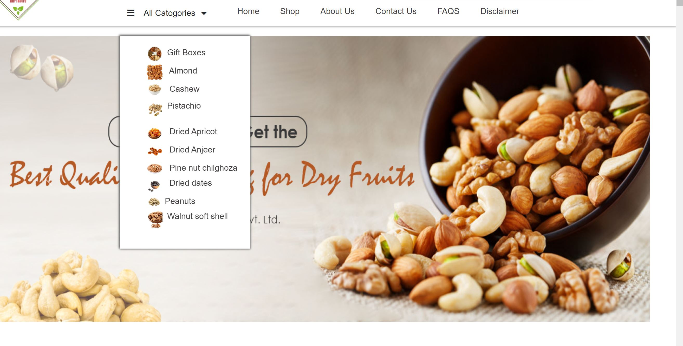

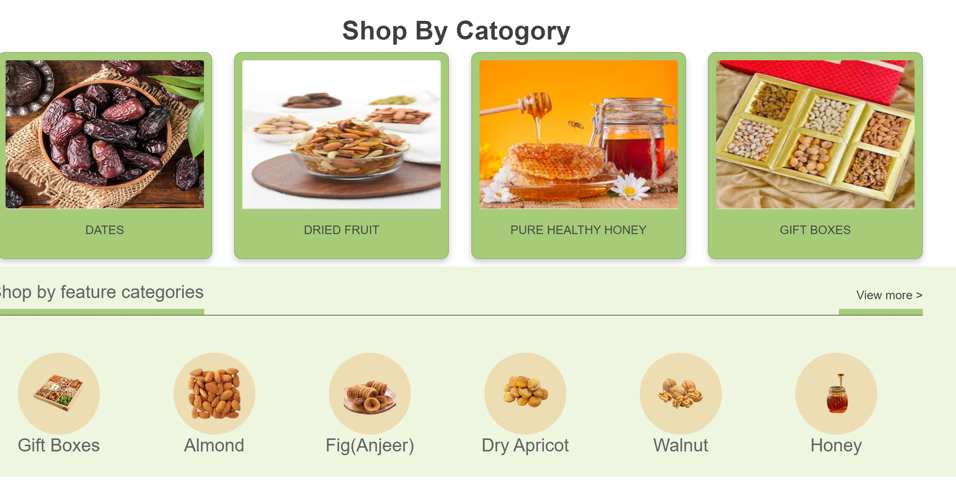

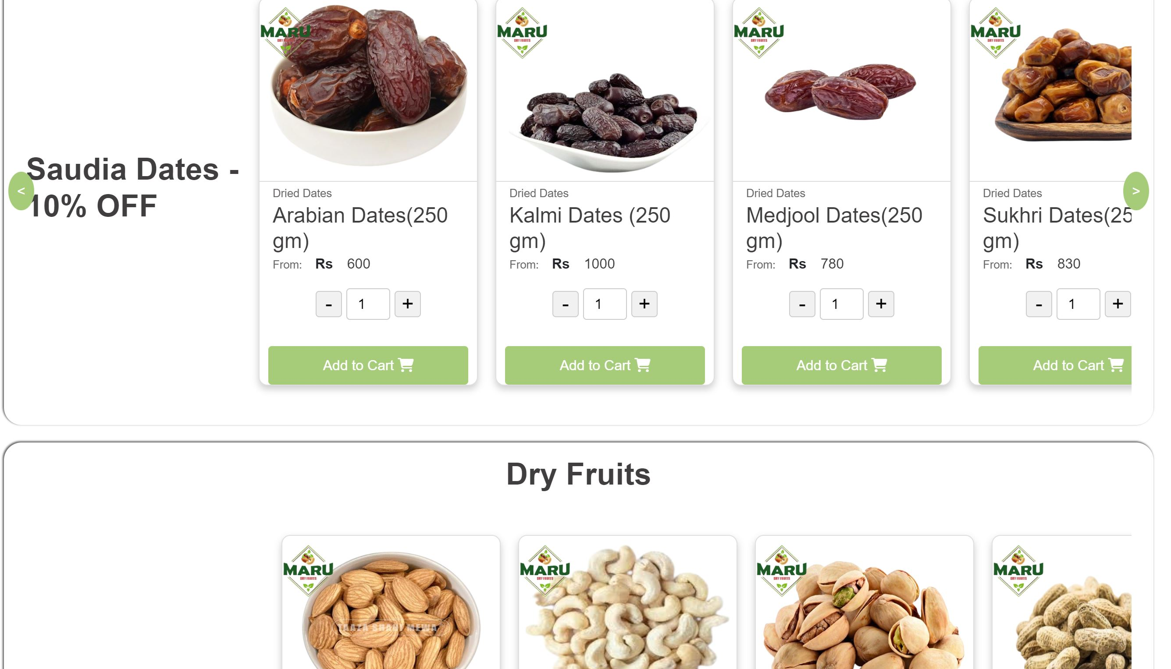

**Code home:**

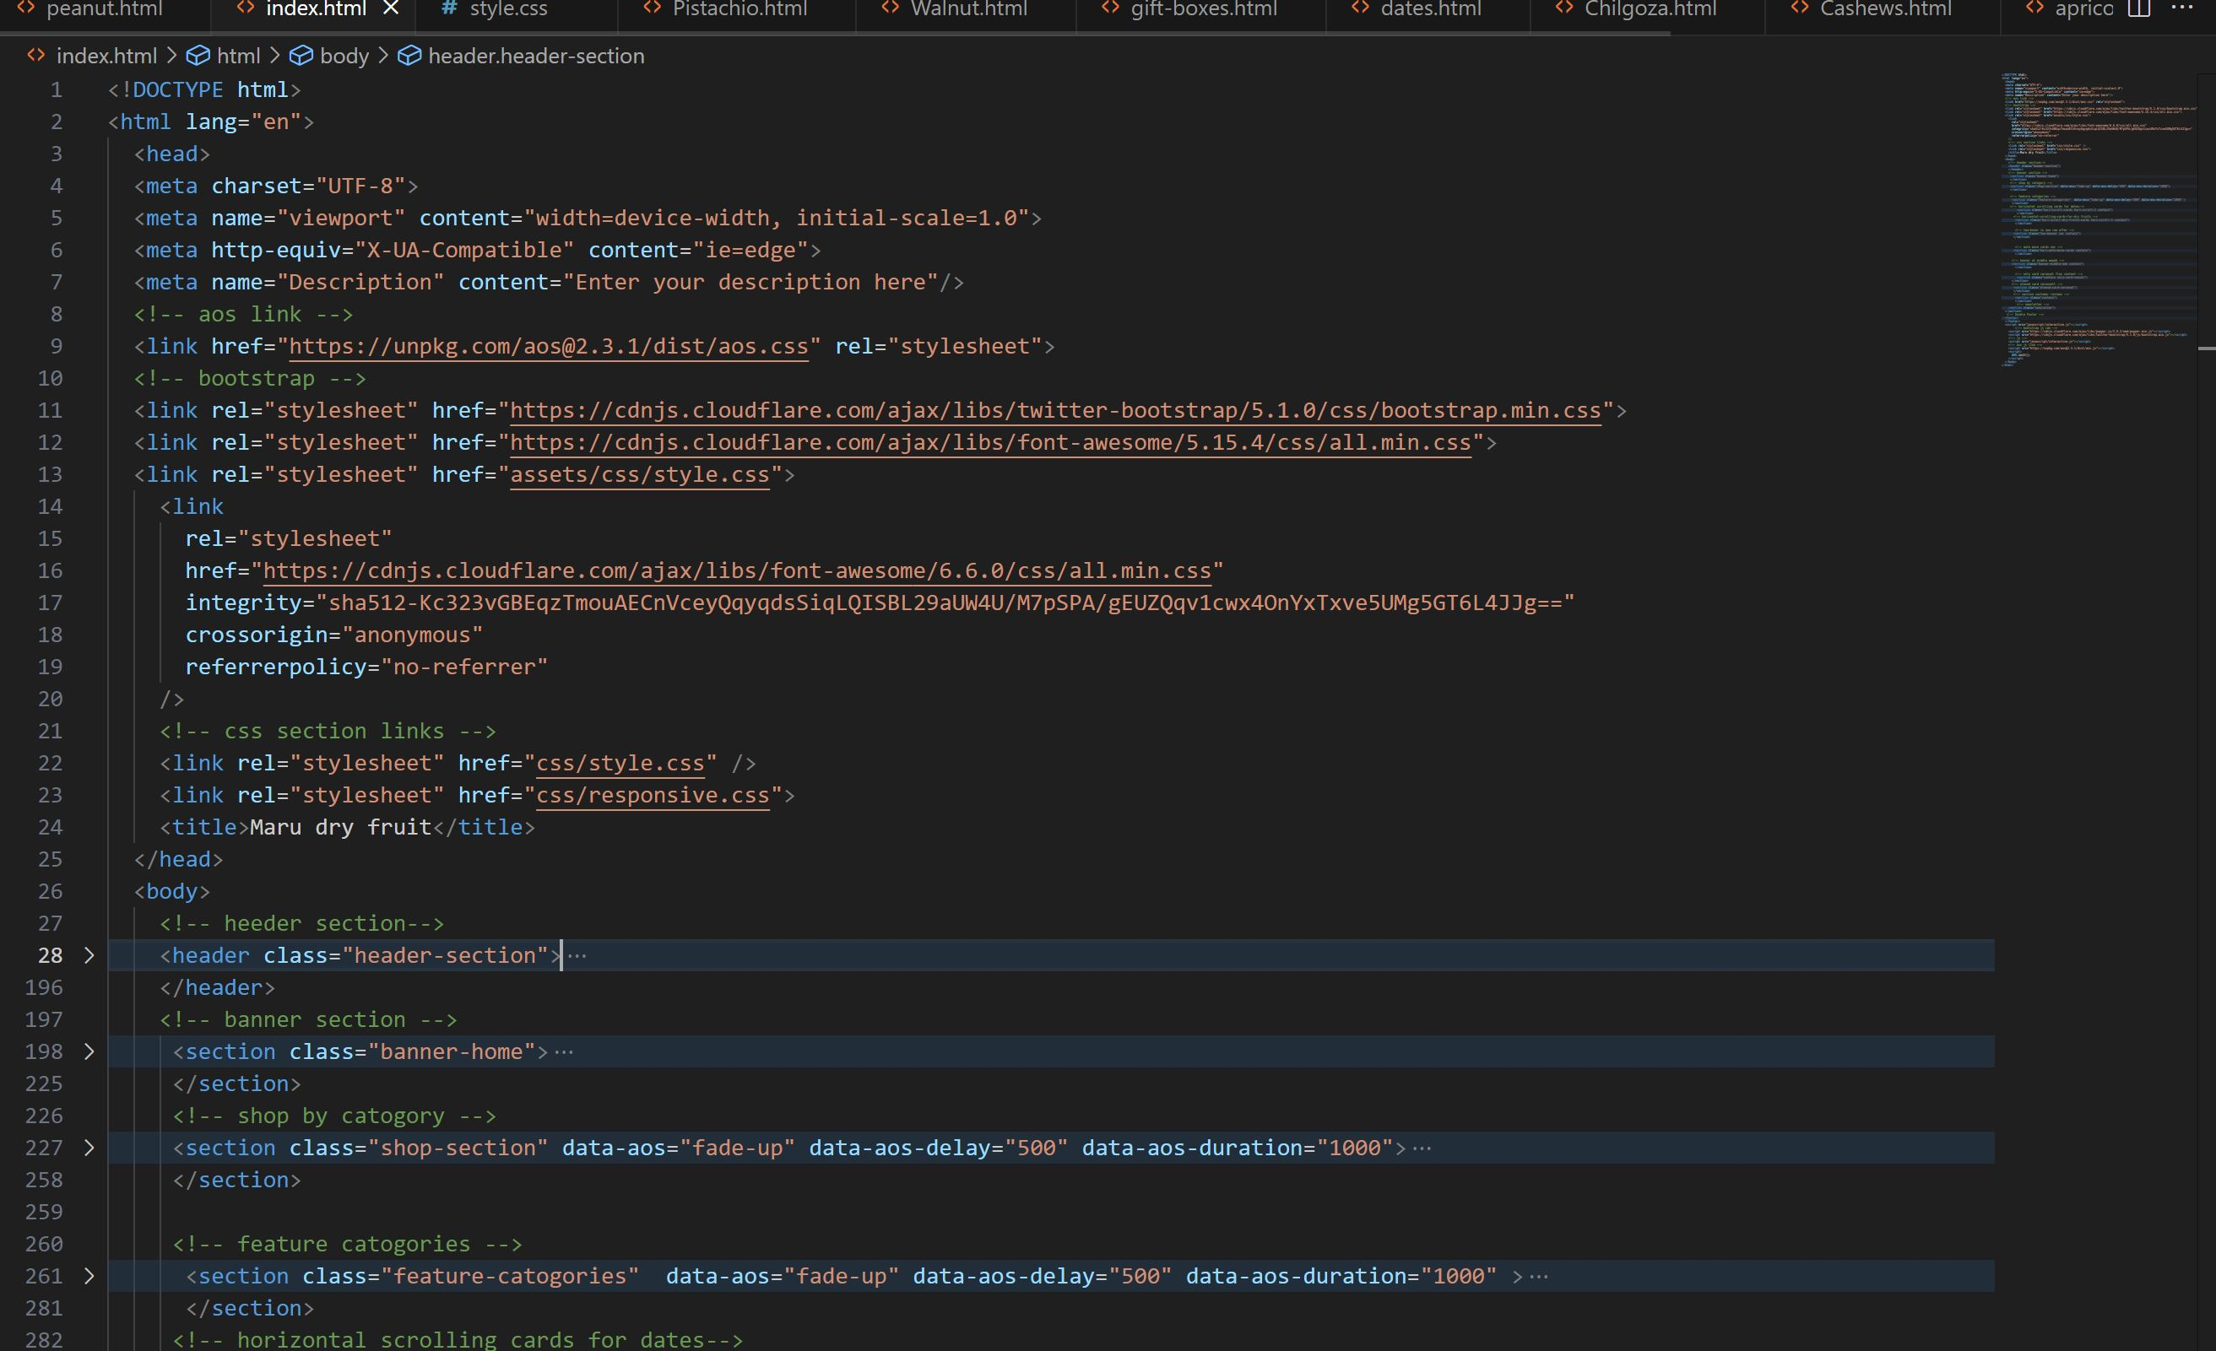



**SHOP**

Maru Dry Fruit Shop is a premium retailer specializing in high-quality dry fruits, nuts, seeds, and healthy snacks. Our store is dedicated to providing customers with a wide variety of nutritious and delicious products sourced from the best producers around the world. We believe in promoting a healthy lifestyle by offering natural and wholesome food options that cater to the needs of health-conscious consumers.

**Product Range:**

* **Dry Fruits:** Almonds, cashews, raisins, figs, dates, apricots, prunes, and more.
* **Nuts & Seeds:** Walnuts, pistachios, sunflower seeds, flaxseeds, chia seeds, and others.
* **Healthy Snacks:** Roasted nuts, mixed nuts, trail mixes, and energy bars.
* **Organic Options:** A selection of organic nuts and dry fruits, free from artificial preservatives and additives.



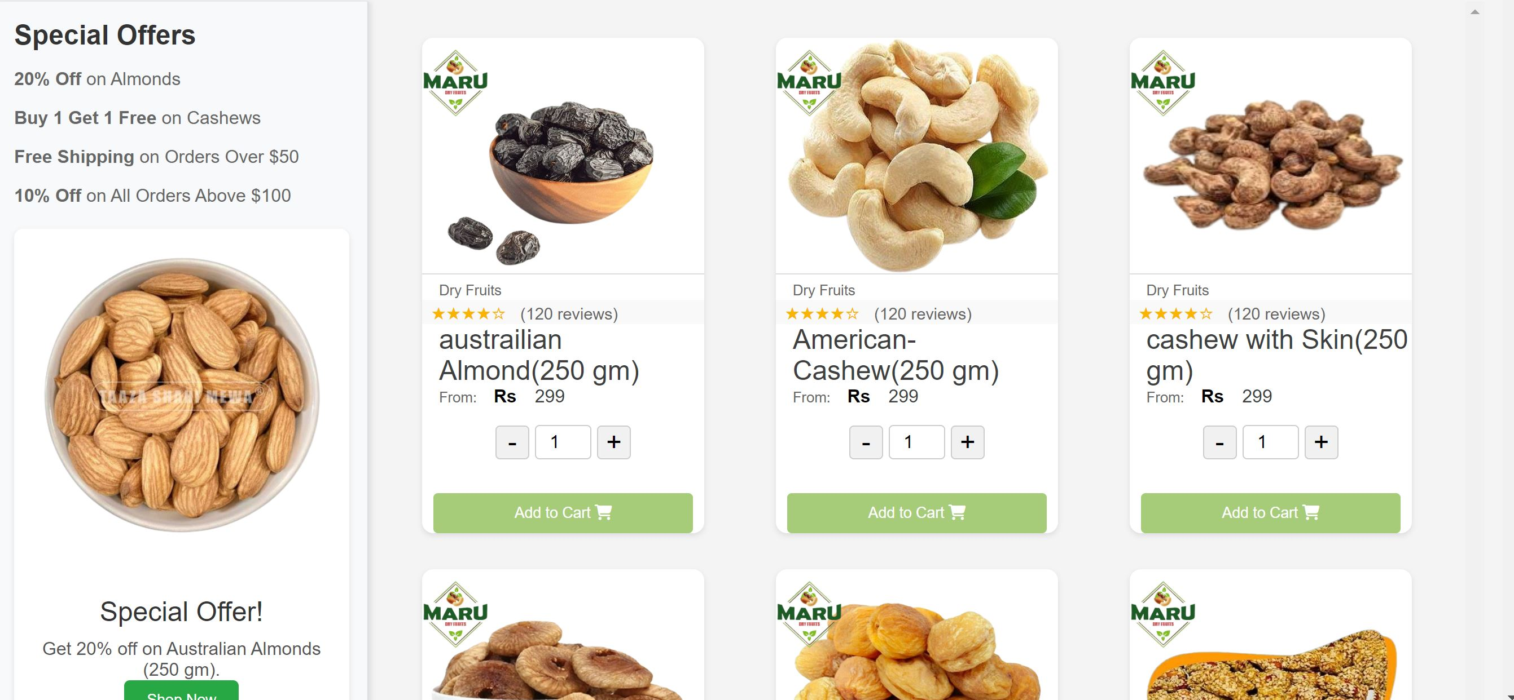

**Code home:**

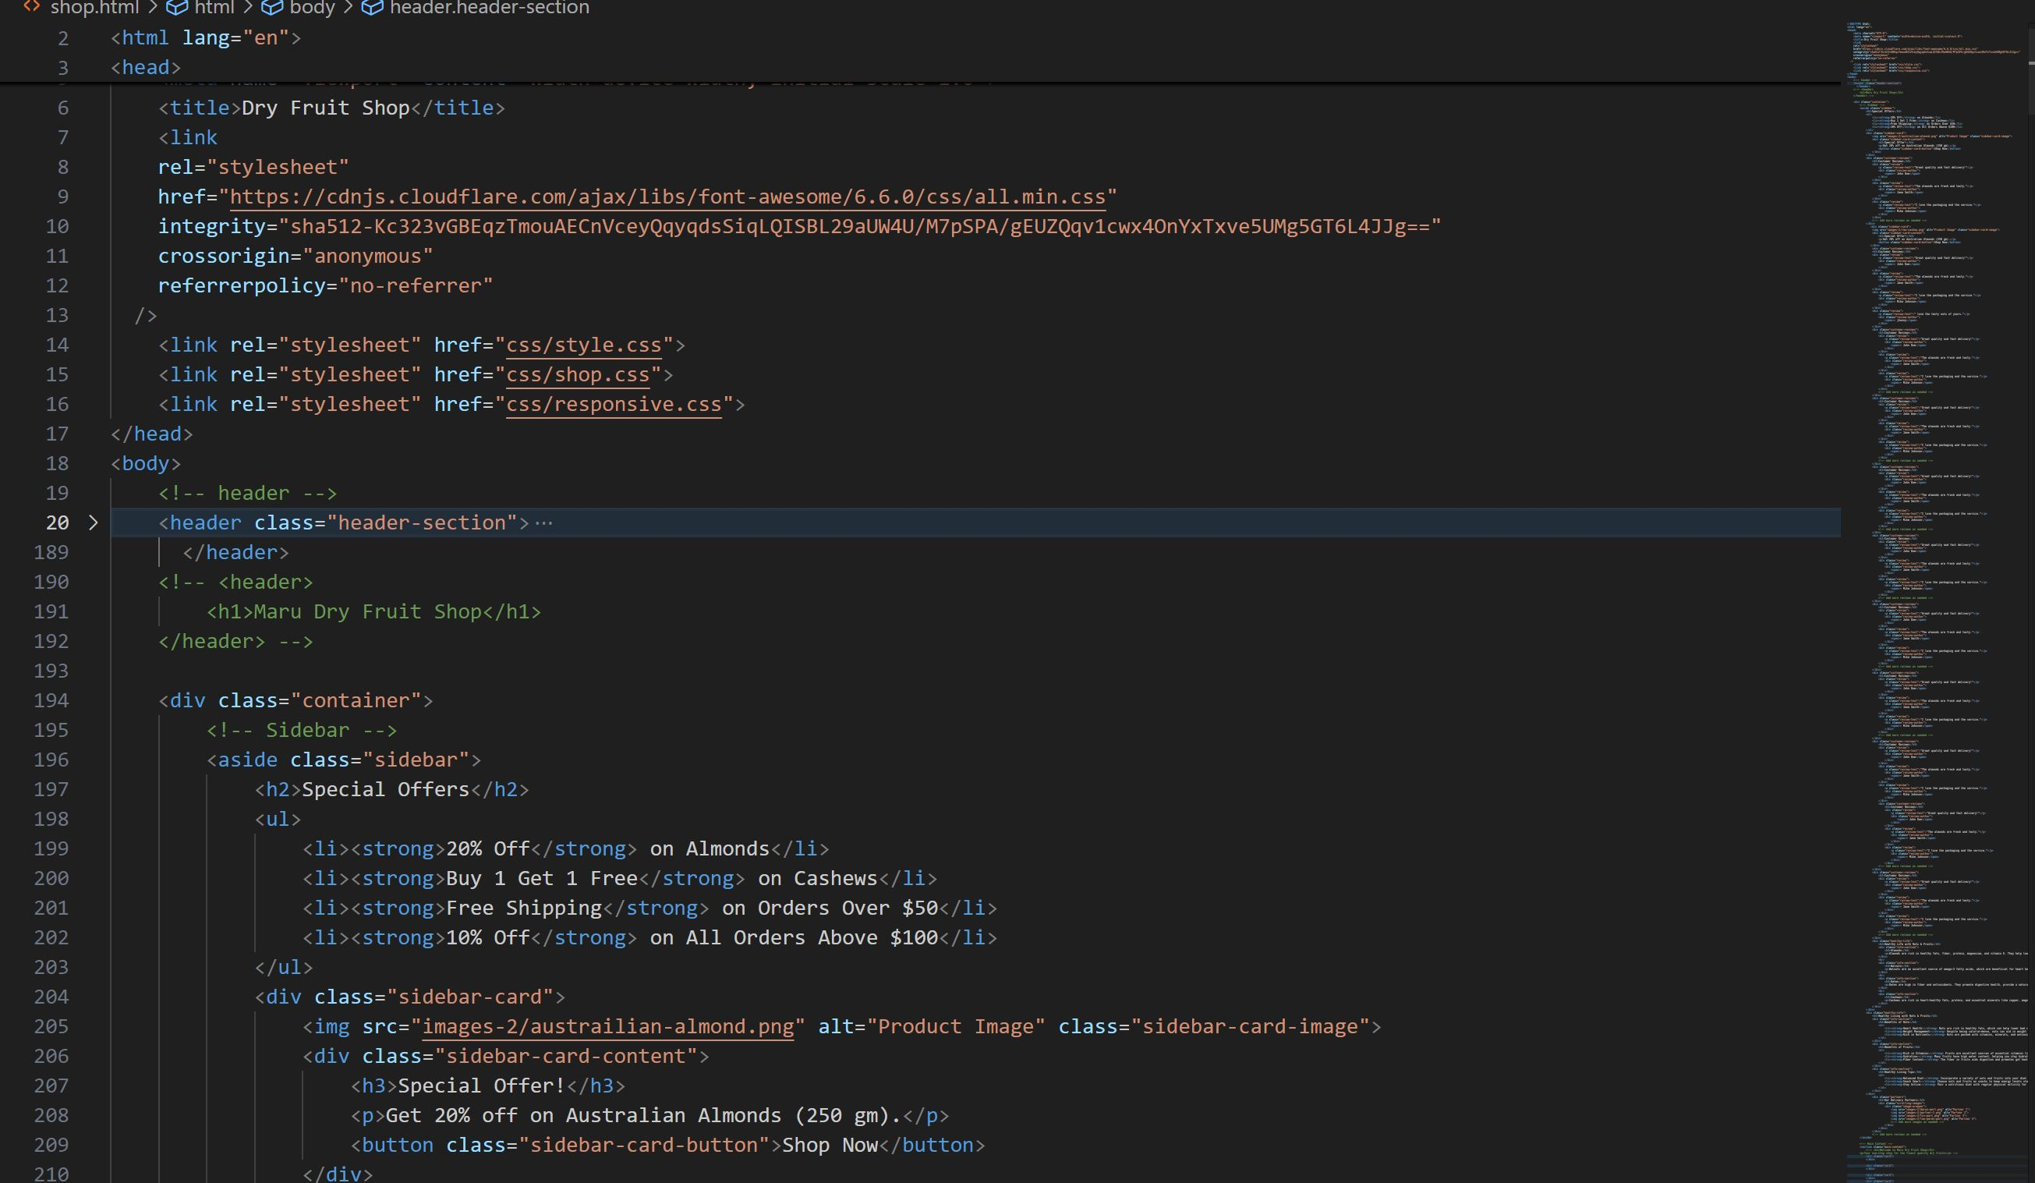



**ABOUT US**

Maru Dry Fruit is a family-owned business dedicated to providing the highest quality dry fruits, nuts, seeds, and healthy snacks to our customers. Founded on the principles of quality, integrity, and customer satisfaction, our shop has grown from a small local store to a trusted name in the community. We take pride in offering a wide range of premium products sourced from the best growers and suppliers around the globe.

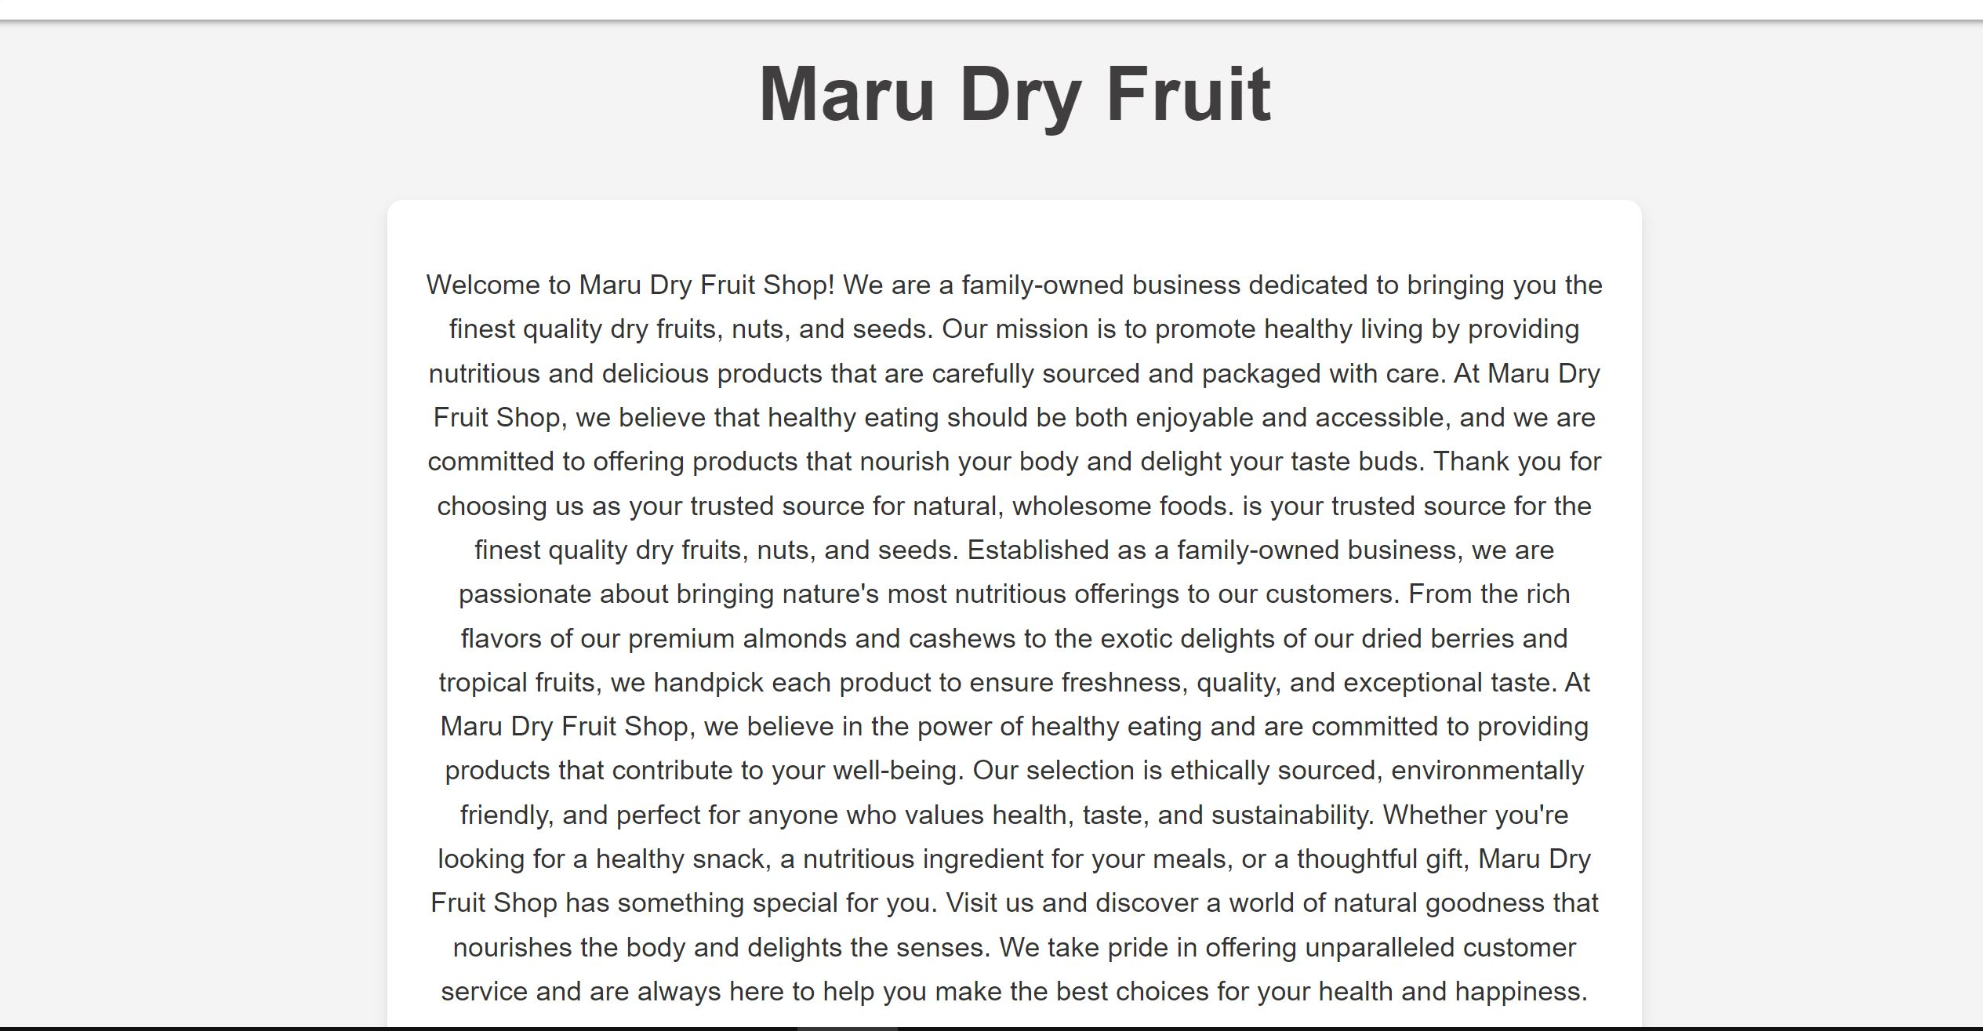



**Code home:**

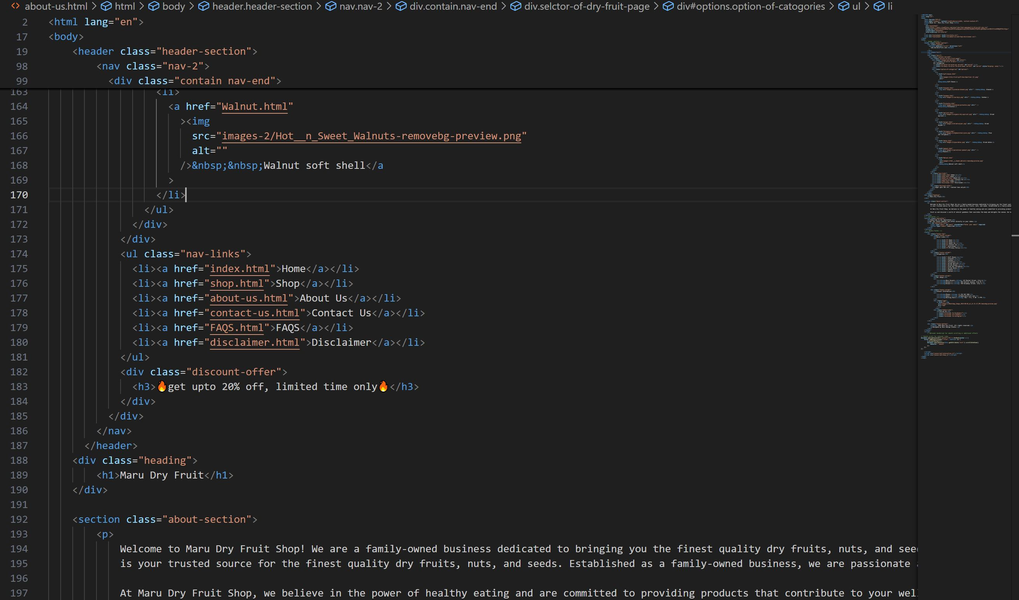

**CONTACT US**

In this page , we add our e-mail, or other personal information that enable other user to get a hold of someone.



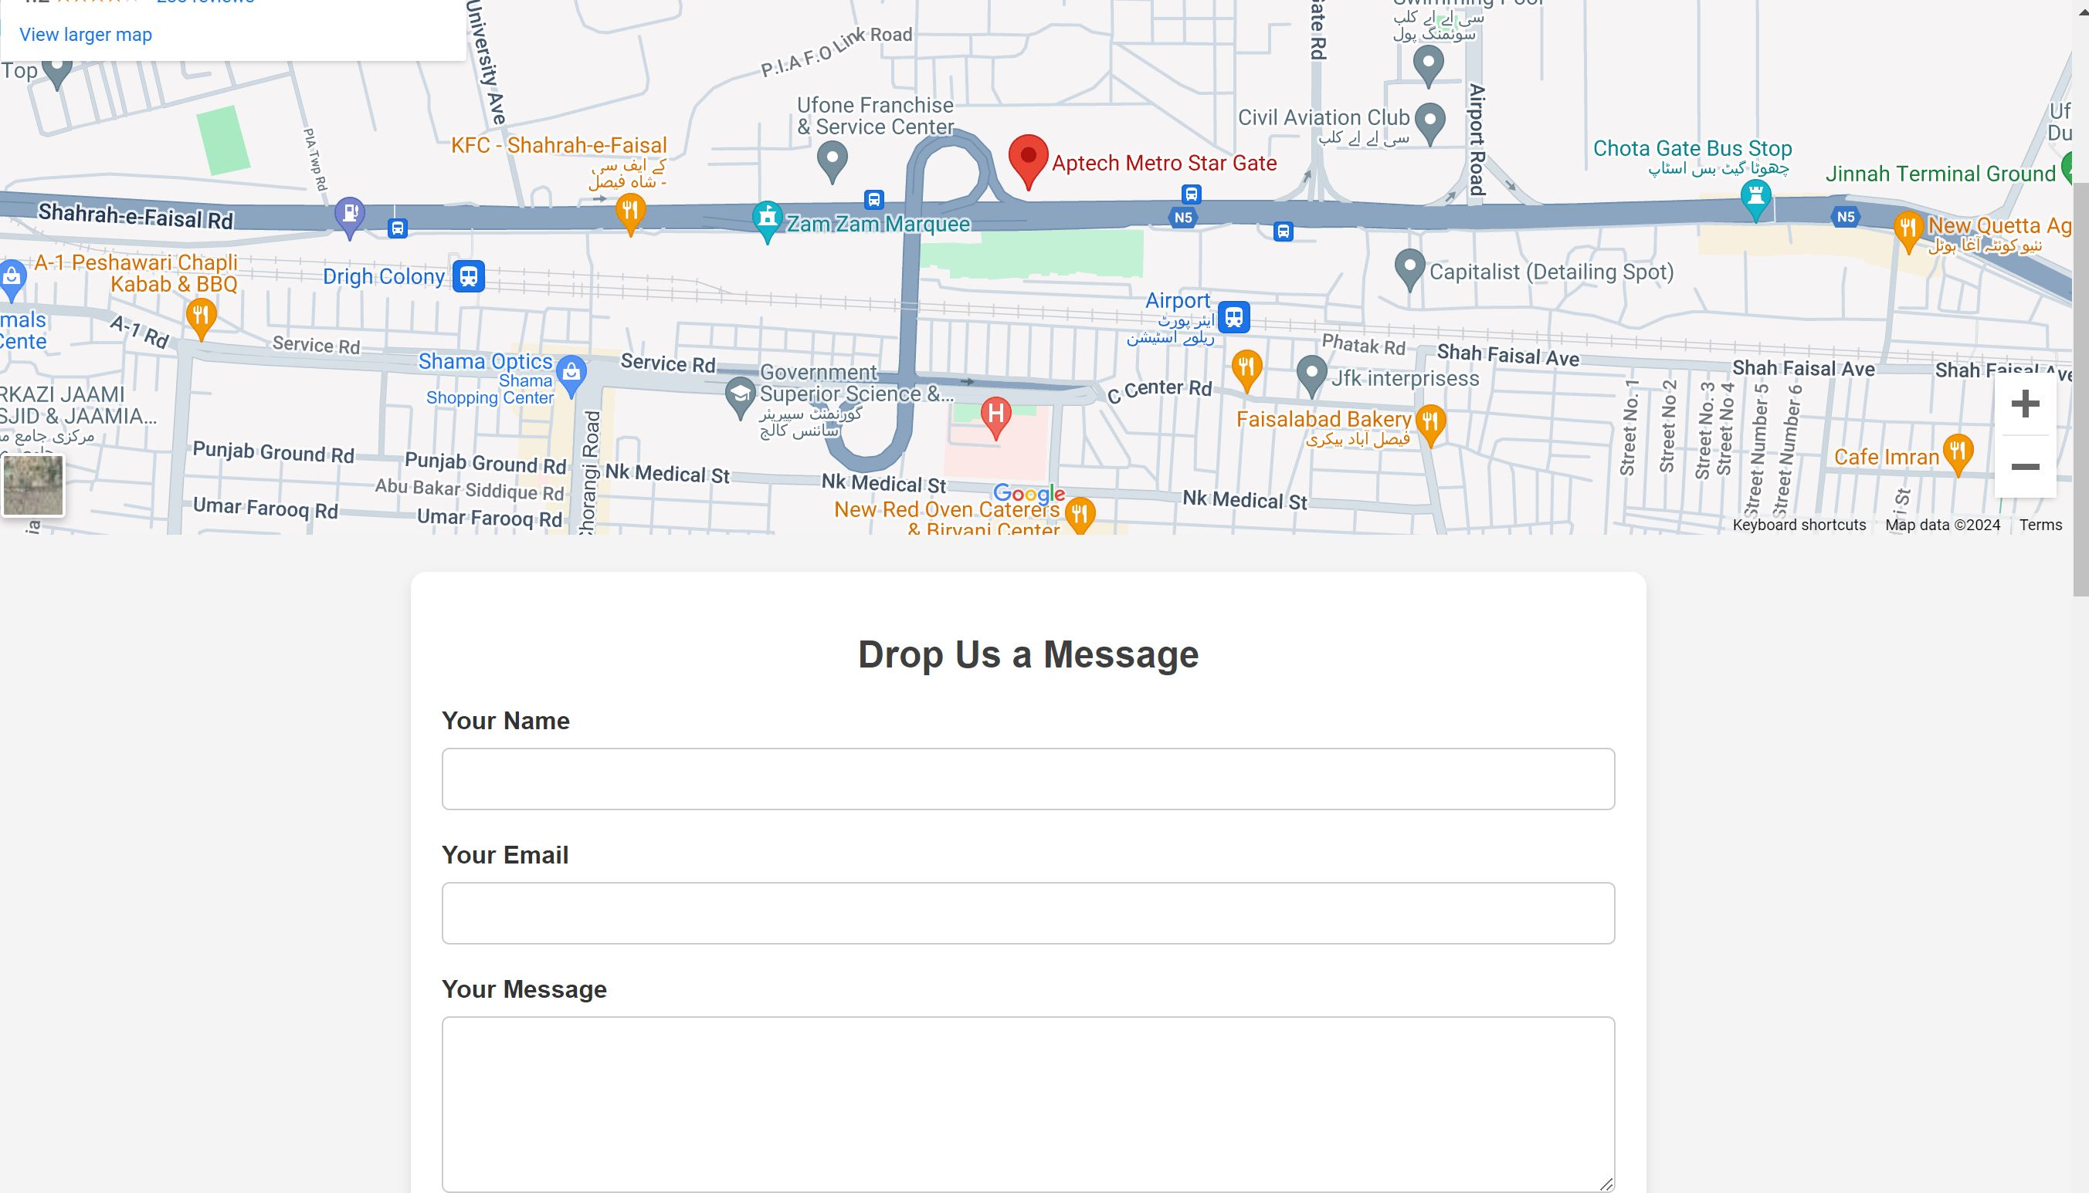**Code home:**

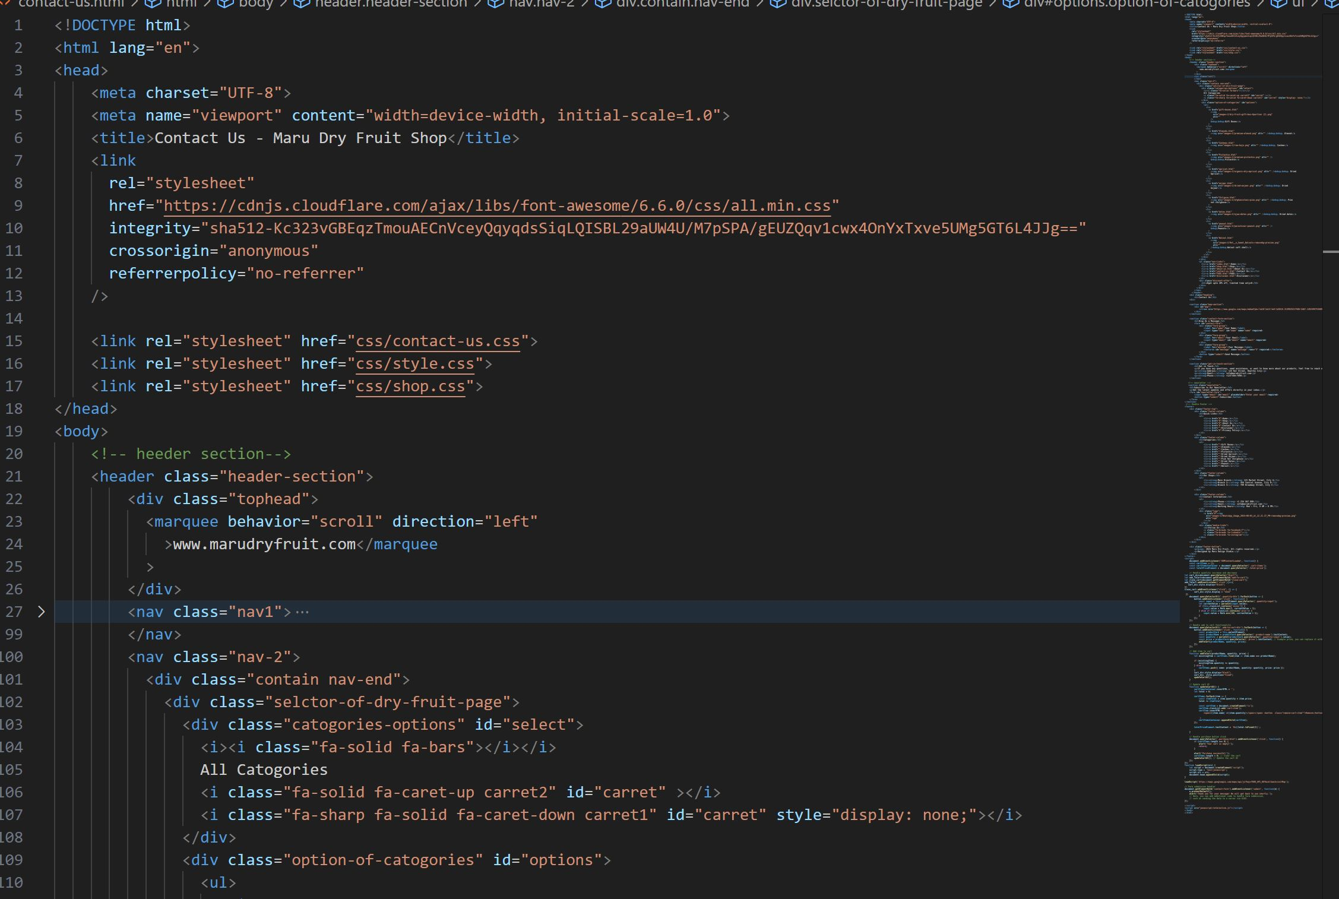



**FAQS**

A list of question and answer relating to a particular subject, especially one giving basic information for user of a website.

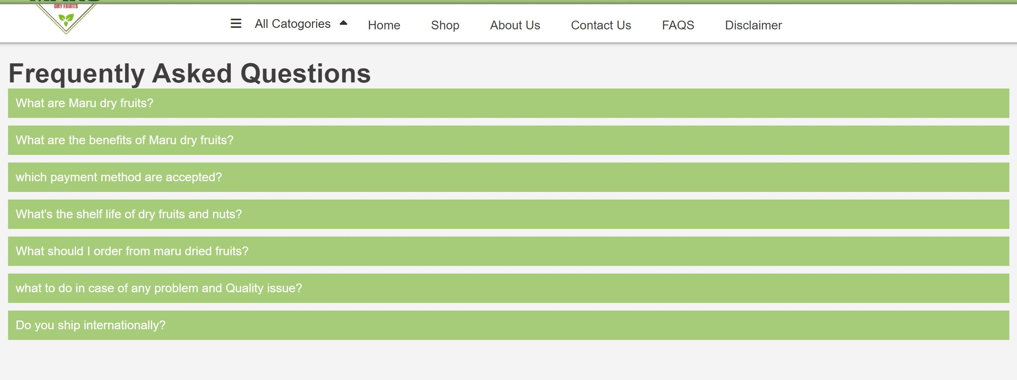

**Code home:**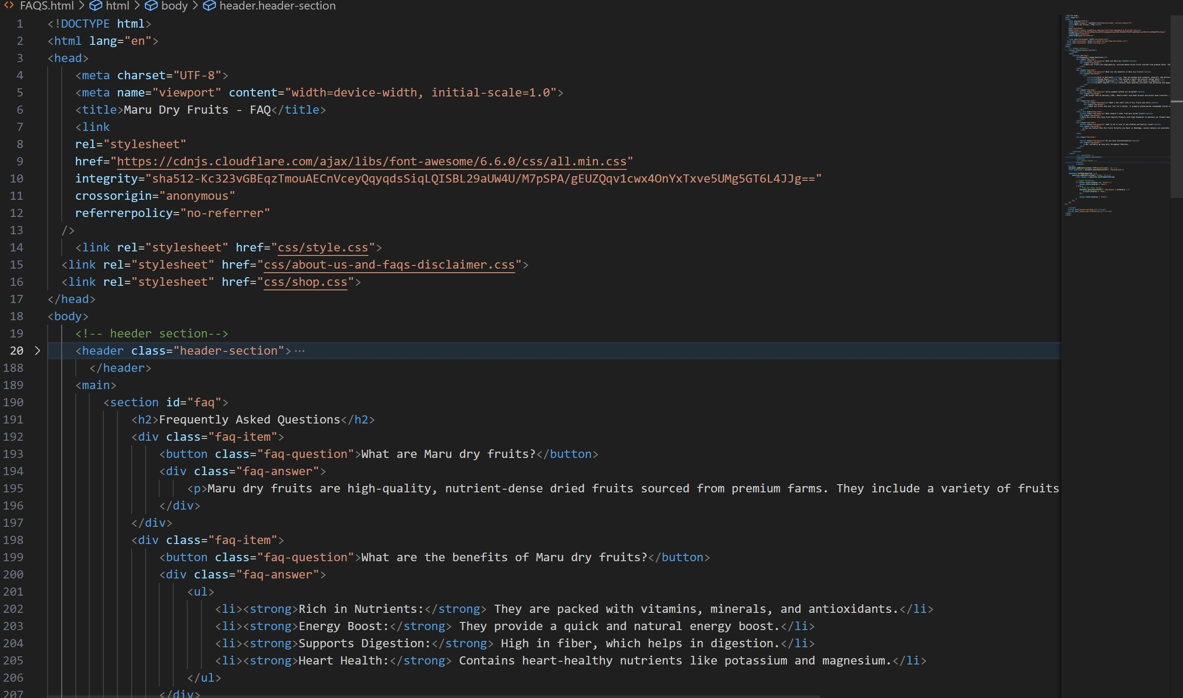



**FOOTER**

**Code home:**

